**Lab 6 Exercise**

1. **Find out all flight schedule information of flight “3310” and “3312”. Make sure to show all the fields.**

**Query:**

select *

from FlightSchedule

where flightNumber IN (3310,3312);

-- Used IN to filter Flight Schedule records with the attribute flightNumber having 3310 & 3312

**Result**:

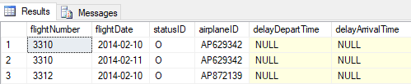

1. **Find all flights departing from airports that start with ‘S’. Show flight number, depart airport, arrival airport, and depart time.**

**Query:**

select flightNumber, departAirport, arriveAirport, scheduledDepartTime from FlightRoute

where departAirport like 'S%';

-- Used like to find pattern starting with S, followed by 0 or many characters

**Result**:

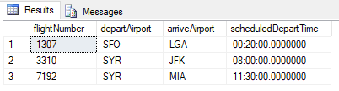

1. **Find 4 most recently purchased planes. Show airplane ID and purchase date only.**

**Query:**

` select top 4 airplaneID, purchaseDate

from Airplane

order by purchaseDate desc;

* Used TOP to select only particular number of records in the top from all the fetched records

**Result**:

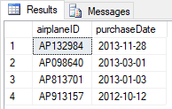

1. **Count the number of flights departing each day. Show the date and the number of flights.**

**Query:**

select flightDate , Count(flightNumber) as NoOfFlights

from FlightSchedule

group by flightDate;

-- Grouped flightSchedule using flightDate and counted flight numbers for each flightDate

**Result**:

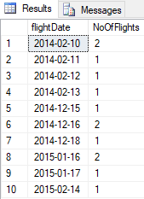

1. **Sort the AircraftSpecs table by fuel capacity in descending order. Show the result with aircraft version and fuel capacity.**

**Query:**

select aircraftVersion, fuelCapacity

from AircraftSpecs

order by fuelCapacity desc;

-- Ordered the records with fuelCapacity in decreasing order

**Result**:

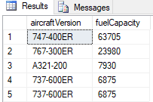

1. **Find all airplanes which flew in the first half of Feb 2014 (From Feb 1- to Feb 14) and the flight status was “on time”. Show airplane ID, flight date, flight number, and status ID.**

**Query:**

select airplaneID, flightDate, flightNumber, statusID

from FlightSchedule

where (flightDate between '2014-2-1' and '2014-2-14') and statusID = 'O';

-- Filtered flightSchedule with status as on time and flightDate between '2014-2-1' and '2014-2-14'

**Result**:

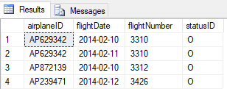

1. **Find all flights which depart from “BOS” after noon. Show flight number, flight date, depart airport and scheduled depart time.**

**Query:**

select a.flightNumber, flightDate, departAirport, scheduledDepartTime

from FlightRoute a Join FlightSchedule b

ON a.flightNumber = b.flightNumber

where departAirport='BOS' and scheduledDepartTime > '12:00';

-- Joined FlightRoute and FlightSchedule using flight number.

-- Filtered records with departAirport='BOS' and scheduledDepartTime afternoon.

**Result**:

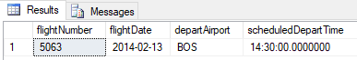

1. **Find all airplanes which were delayed or cancelled. Show only airplane ID, flight date and status description.**

**Query:**

select a.airplaneID, a.flightDate, b.description as [description]

from FlightSchedule a Join FlightStatus b ON a.statusID = b.statusID

where a.statusID IN ('C','D');

-- Joined FlightSchedule and FlightStatus using statusID.

-- Filtered records with statusID cancelled or delayed.

**Result**:

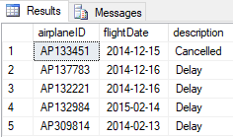

1. **Find the flight(s) which are “on time”, display the Flight number and departure airport**

**Query:**

select a.flightNumber, b.departAirport

from FlightSchedule a Join FlightRoute b

ON a.flightNumber = b.flightNumber

where a.statusID ='O';

-- Joined FlightSchedule and FlightRoute using flightNumber.

-- Filtered records with statusID on time.

**Result**:

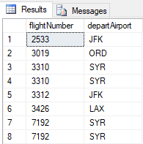

**j) Find all the airplanes that have not been scheduled to fly. *(You can use Left Join)***

**Query:**

select a.*, b.delayArrivalTime,b.delayDepartTime, b.flightDate, b.flightNumber, b.statusID

from Airplane a left Join FlightSchedule b

on a.airplaneID = b.airplaneID

where b.statusID ='C';

-- Left joined Airplane table with FlightSchedule table.

-- Filtered records with statusID as cancelled.

**Result**:

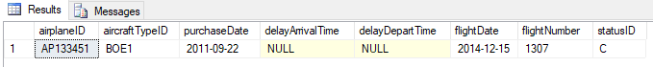

**k)** **Find all only airplanes that have been scheduled to fly and delayed. Display Airplane ID of the flight (Use Right Join)**

**Query:**

select a.airplaneID

from FlightSchedule b right Join Airplane a

on b.airplaneID = a.airplaneID

where statusID ='D';

-- Right joined FlightSchedule table with Airplane table.

-- Filtered records with statusID as delayed.

**Result**:

